**Parking System**

**Android Application –**

**System Manual**

**CONTENTS**

**Title** **Page No.**

1. **GENERAL INFORMATION 3** 
   1. Important 3
   2. Acknowledgement 3
   3. Legal Notice 3
   4. Foreword 3
2. **Objectives 4** 
   1. Functional Use 4
   2. Space requirements 4
   3. Special requirements 4
   4. Feedback messages 4
   5. Cost saving 4
   6. Document and training needs 4
3. **Overview of app 5 - 7**
   1. Logging page 5
   2. Search vacant parking spots 6
   3. Send feedback messages 7

**4.0 Admin functionalities 8-9**

4.1 Updating users 8

4.2 Updating parking spots 9

**1.0 General Information**

**1.1 IMPORTANT**: This system manual is for instructional purpose. The document gives the user an idea on how to install the application in android phone and what are the system requirements. This document will help the user in knowing the system requirements so that they can easily install the app and use it.

**1.2 ACKNOWLEDGEMENTS**: This document is based upon the work from Android parking system. The app is mainly developed to help user find easy parking spots.

* 1. **LEGAL NOTICE**: This document does not:

1. Makes any written or oral warranty, expressed or implied, including, but not limited to those concerning merchantability or fitness for a particular purpose
2. Assumes any legal liability or responsibility for the accuracy, completeness, or usefulness of any information, apparatus, product, process, method, or policy contained herein; or
3. Represents that its use would not infringe any privately owned rights, including, but not limited to, patents, trademarks, or copyrights.

**1.4 Foreword**:

The systems manual is meant to inform students, faculty, outsiders as well as facility occupants as to the basis for operating parking application. It is intended to be useful in the day-to-day operations. It also forms the basis for operating and maintaining UPD systems. Information that could be included in a systems manual if available is listed below.

* A general description of how to install the app.
* A brief clue of system requirement for installing the app.
* A major description including the app details and helpful information about the map of the parking spots guiding the users to park their vehicles.
* A list of necessary training requirements or issues.
* A list of relevant documentation identifying responsible party.
* A questionnaire that guides new supervisors in acquiring relevant information from the UPD.

**2.0 Objectives**:

Provide a parking guidance to the users to support them park their vehicles. The current goal of this document is to meet both the UPD need and the users need.

**2.1 Functional Uses/Operational Capabilities**: The app provides the user the guidance to park their vehicles. The application guides the user after registering to the app to search for the vacant spots, check the number of parking spots and then give the feedback to the UPD.

**2.2 Space requirements:** The android app should go to google store then download the app. Then the phone should have 50 mb space free minimum to install the app. The app can be downloaded from the google store. Personnel from all the fields that is students, faculty, and other users can install the app and use it to park their vehicles. They can search the vacant spots and check the number of parking spots. Then they can send the messages to the university police department.

**2.3 Special requirements**: Special requirement include that a user should be android user to be able to download the app. The users should be able to register themselves to use the app. The users should search for the vacant spots through the map and then send the feedback messages to the university police department.

**2.4 Feedback message**: The users once registered can send the feedback messages to the university police department.

**2.5 Utility/ cost saving**: The app incorporates the budget of the university police department. Also the users can install the app for free of cost and register themselves for free and use the app.

**2.6 Documentation and Training Needs**: The document that user needs to train themselves includes the user manual to know more about the app. The user should know how to use the app after registering themselves.

**3.0 Overview of app**

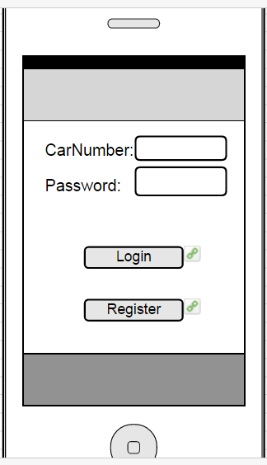

3.1 Register page: The user can login to the app.

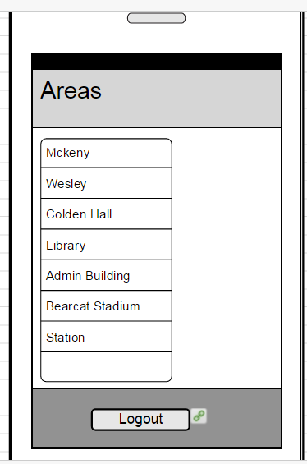

3.2 Search parking spots The user can search for the vacant parking spots.

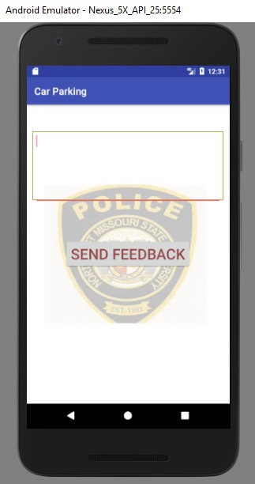

3.3 feedback messages: The user then can send the feedback message to the university police department.

1. **Admin functionalities**

4.1 **Adding/deleting users**

As parking system android app has used the back4app as the cloud database admin can add/delete users directly by logging into his account.

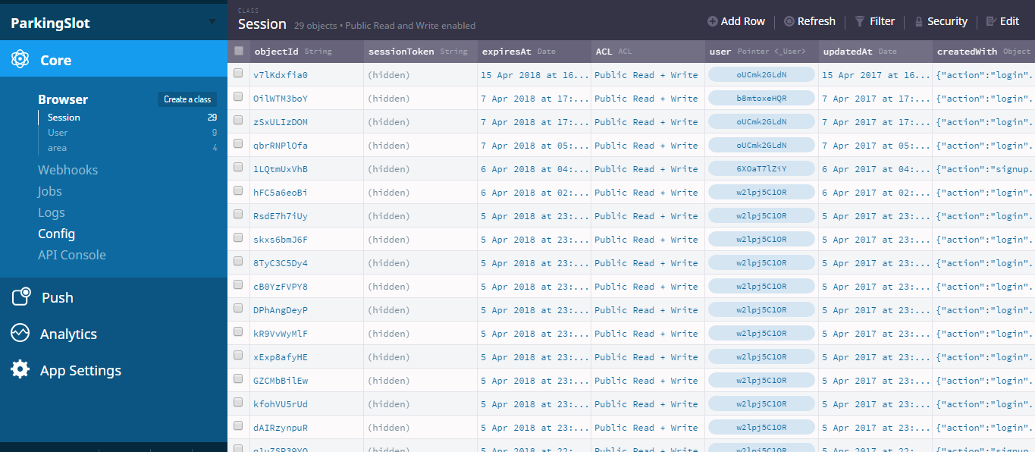

Admin will get the overview of logging in sessions as above

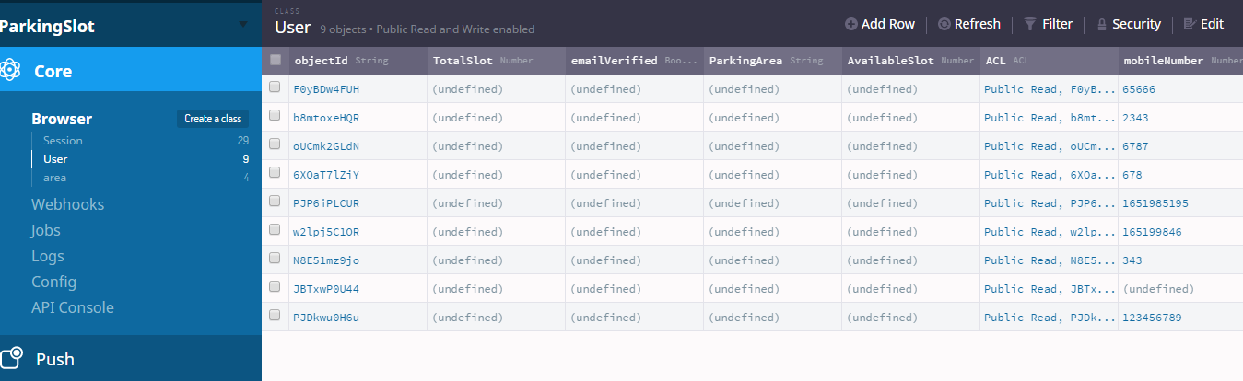

Admin can see the objected, email verified, mobile number of the users. We have made different attributes for it. The admin can then delete users if he finds any fraud by using the “edit” tab at the top of the page.

4.2 **Adding/Deleting parking spots**

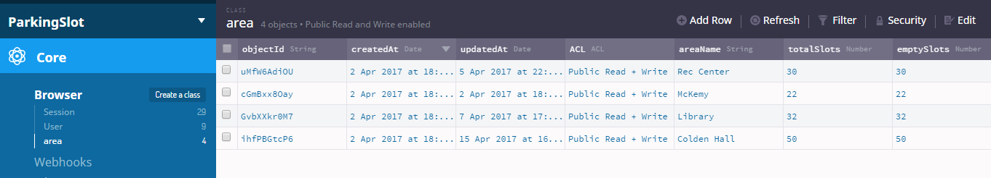

Likewise admin can add/delete new parking areas as per the need of the university police department. If the admin wants to add the new parking spot he should use the edit tab above.

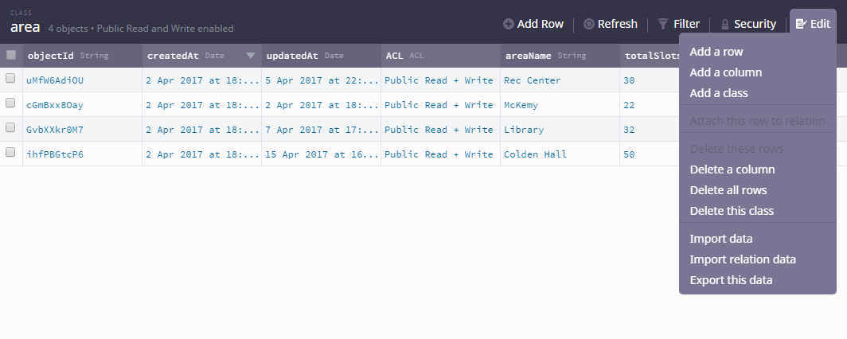

Clear view of “edit” tab.